**Java Stack Class**

The Java collections framework has a class named Stack that provides the functionality of the stack data structure.

The Stack class extends the Vector class.

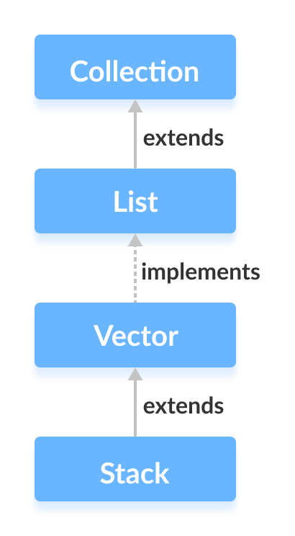

## Stack Implementation

In stack, elements are stored and accessed in **Last In First Out** manner. That is, elements are added to the top of the stack and removed from the top of the stack.

## Creating a Stack

In order to create a stack, we must import the java.util.Stack package first. Once we import the package, here is how we can create a stack in Java.

Stack<Type> stacks = new Stack<>();

Here, Type indicates the stack's type. For example,

// Create Integer type stack

Stack<Integer> stacks = new Stack<>();

// Create String type stack

Stack<String> stacks = new Stack<>();

## Stack Methods

Since Stack extends the Vector class, it inherits all the methods Vector. To learn about different Vector methods, visit Java Vector Class.

Besides these methods, the Stack class includes 5 more methods that distinguish it from Vector.

### push() Method

To add an element to the top of the stack, we use the push() method. For example,

import java.util.Stack;

class Main {

public static void main(String[] args) {

Stack<String> animals= new Stack<>();

// Add elements to Stack

animals.push("Dog");

animals.push("Horse");

animals.push("Cat");

System.out.println("Stack: " + animals);

}

}

**Output**

Stack: [Dog, Horse, Cat]

### pop() Method

To remove an element from the top of the stack, we use the pop() method. For example,

import java.util.Stack;

class Main {

public static void main(String[] args) {

Stack<String> animals= new Stack<>();

// Add elements to Stack

animals.push("Dog");

animals.push("Horse");

animals.push("Cat");

System.out.println("Initial Stack: " + animals);

// Remove element stacks

String element = animals.pop();

System.out.println("Removed Element: " + element);

}.

}

**Output**

Initial Stack: [Dog, Horse, Cat]

Removed Element: Cat

### peek() Method

The peek() method returns an object from the top of the stack. For example,

import java.util.Stack;

class Main {

public static void main(String[] args) {

Stack<String> animals= new Stack<>();

// Add elements to Stack

animals.push("Dog");

animals.push("Horse");

animals.push("Cat");

System.out.println("Stack: " + animals);

// Access element from the top

String element = animals.peek();

System.out.println("Element at top: " + element);

}

}

**Output**

Stack: [Dog, Horse, Cat]

Element at top: Cat

### search() Method

To search an element in the stack, we use the search() method. It returns the position of the element from the top of the stack. For example,

import java.util.Stack;

class Main {

public static void main(String[] args) {

Stack<String> animals= new Stack<>();

// Add elements to Stack

animals.push("Dog");

animals.push("Horse");

animals.push("Cat");

System.out.println("Stack: " + animals);

// Search an element

int position = animals.search("Horse");

System.out.println("Position of Horse: " + position);

}

}

**Output**

Stack: [Dog, Horse, Cat]

Position of Horse: 2

### empty() Method

To check whether a stack is empty or not, we use the empty() method. For example,

import java.util.Stack;

class Main {

public static void main(String[] args) {

Stack<String> animals= new Stack<>();

// Add elements to Stack

animals.push("Dog");

animals.push("Horse");

animals.push("Cat");

System.out.println("Stack: " + animals);

// Check if stack is empty

boolean result = animals.empty();

System.out.println("Is the stack empty? " + result);

}

}

**Output**

Stack: [Dog, Horse, Cat]

Is the stack empty? false

## Use ArrayDeque Instead of Stack

The Stack class provides the direct implementation of the stack data structure. However, it is recommended not to use it. Instead, use the ArrayDeque class (implements the Deque interface) to implement the stack data structure in Java.

To learn more, visit:

* Java ArrayDeque
* Why use Deque over Stack?